DeadLock simulation with extended events and trace:
Add trace to the server startup parameters:
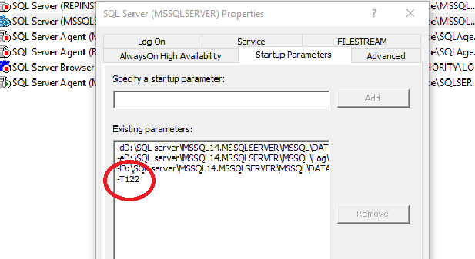
OR
DBCC traceon (1222, -1)
-1 = global level. Without -1 will be only in session level. -> DBCC traceon (1222)
To check the status: DBCC TraceStatus (1222, -1)
Create an online extended event:

Get deadlock:
See trace:
execute sp_readerrorlog
And in sql server log:

